Dependency Manager
# Source: AI Source: Provided by: [Data Path: Persons Table -> ID Column: 1, Name_En Column: Motasem Essam] -> From: [ChatGPT] on [1/26/2026]
A Dependency Manager is a tool that automatically handles the software libraries (dependencies) your project needs to run, build, or compile properly.
Examples:
- pip with requirements.txt in Python
- npm or yarn in Node.js
- Maven or Gradle in Java

🔧 What Is a Dependency?
# Source: AI Source: Provided by: [Data Path: Persons Table -> ID Column: 1, Name_En Column: Motasem Essam] -> From: [ChatGPT] on [1/26/2026]
A dependency is any external code or library your project relies on.
For example:
- A Python web app may depend on Flask
- A Node.js project may depend on express
- A C++ project may depend on libcurl

📦 What a Dependency Manager Does:
# Source: AI Source: Provided by: [Data Path: Persons Table -> ID Column: 1, Name_En Column: Motasem Essam] -> From: [ChatGPT] on [1/26/2026]
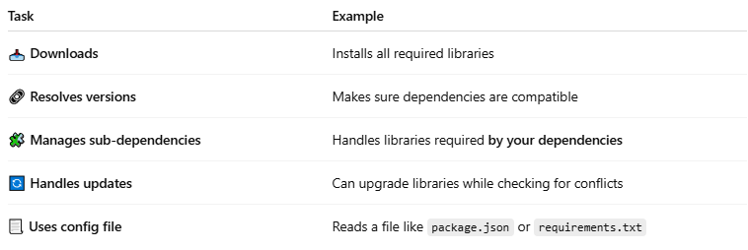

Task | Example
📥 Downloads | Installs all required libraries
🔗 Resolves versions | Makes sure dependencies are compatible
🧩 Manages sub-dependencies | Handles libraries required by your dependencies
🔄 Handles updates | Can upgrade libraries while checking for conflicts
📃 Uses config file | Reads a file like package.json or requirements.txt

🧪 Examples by Language
# Source: AI Source: Provided by: [Data Path: Persons Table -> ID Column: 1, Name_En Column: Motasem Essam] -> From: [ChatGPT] on [1/26/2026]
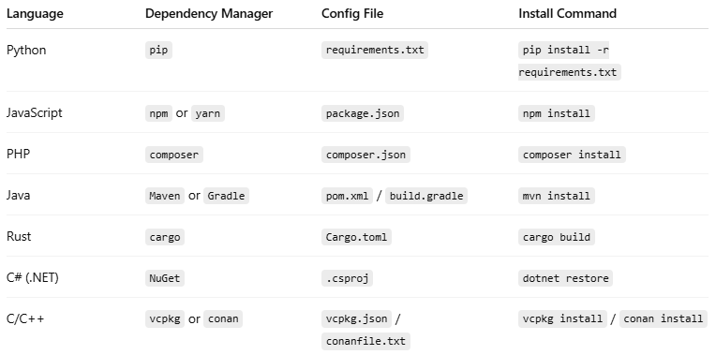

Language | Dependency Manager | Config File | Install Command
Python | pip | requirements.txt | pip install -r requirements.txt
JavaScript | npm or yarn | package.json | npm install
PHP | composer | composer.json | composer install
Java | Maven or Gradle | pom.xml / build.gradle | mvn install
Rust | cargo | Cargo.toml | cargo build
C# (.NET) | NuGet | .csproj | dotnet restore
C/C++ | vcpkg or conan | vcpkg.json / conanfile.txt | vcpkg install / conan install

🧠 Why Use a Dependency Manager?
# Source: AI Source: Provided by: [Data Path: Persons Table -> ID Column: 1, Name_En Column: Motasem Essam] -> From: [ChatGPT] on [1/26/2026]
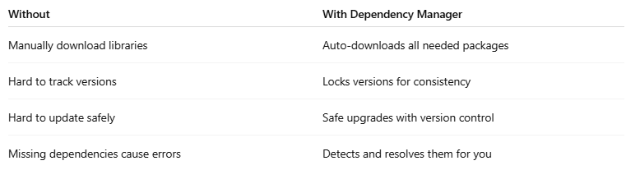

Without | With Dependency Manager
Manually download libraries | Auto-downloads all needed packages
Hard to track versions | Locks versions for consistency
Hard to update safely | Safe upgrades with version control
Missing dependencies cause errors | Detects and resolves them for you

"run," "build," or "compile
# Source: AI Source: Provided by: [Data Path: Persons Table -> ID Column: 1, Name_En Column: Motasem Essam] -> From: [ChatGPT] on [1/26/2026]
Let’s break down what it means for a project to "run," "build," or "compile properly", especially in the context of software development and dependency managers.

⚙️ 1. Run Properly
# Source: AI Source: Provided by: [Data Path: Persons Table -> ID Column: 1, Name_En Column: Motasem Essam] -> From: [ChatGPT] on [1/26/2026]
- "Run" means the program starts and works correctly.
- This is what happens when you execute or launch the app.
✅ Example:
- A Python app using Flask won't run unless Flask is installed.
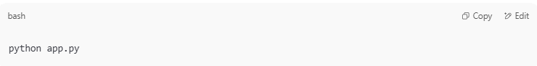
python app.py

If Flask is missing, you'll get an error like:
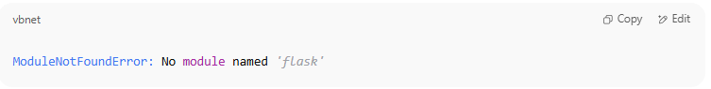
ModuleNotFoundError: No module named 'flask'

🛠️ 2. Build Properly
# Source: AI Source: Provided by: [Data Path: Persons Table -> ID Column: 1, Name_En Column: Motasem Essam] -> From: [ChatGPT] on [1/26/2026]
- "Build" means the project is prepared for running — especially for web apps or compiled apps.
- This might involve:
  - Combining files (HTML/CSS/JS)
  - Optimizing images or code
  - Resolving dependencies
  - Outputting to a build/ folder
✅ Example:
- A React web app needs to build before it's deployed:
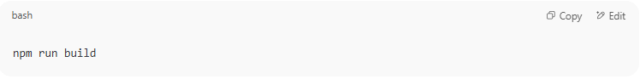
npm run build

This command processes all your source code into a final version for the browser.

🧱 3. Compile Properly
# Source: AI Source: Provided by: [Data Path: Persons Table -> ID Column: 1, Name_En Column: Motasem Essam] -> From: [ChatGPT] on [1/26/2026]
- "Compile" means the source code (like C, C++, Java) is translated into executable code (binary/machine code).
- Compilation fails if:
  - Code has syntax errors
  - A required library is missing

✅ Example:
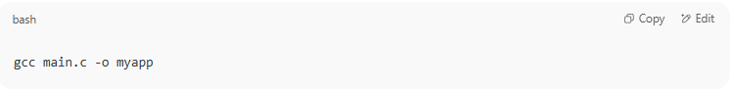
gcc main.c -o myapp

If a needed .h file or library is missing, you’ll get a compile-time error.

🧠 Summary Table:
# Source: AI Source: Provided by: [Data Path: Persons Table -> ID Column: 1, Name_En Column: Motasem Essam] -> From: [ChatGPT] on [1/26/2026]
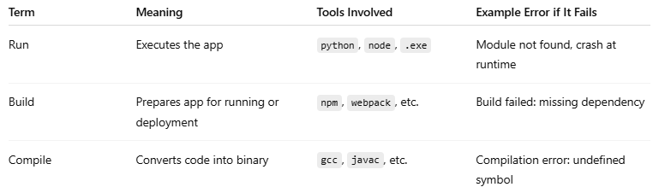

Term | Meaning | Tools Involved | Example Error if It Fails
Run | Executes the app | python, node, .exe | Module not found, crash at runtime
Build | Prepares app for running or deployment | npm, webpack, etc. | Build failed: missing dependency
Compile | Converts code into binary | gcc, javac, etc. | Compilation error: undefined symbol

🔗 Connection to Dependency Managers:
# Source: AI Source: Provided by: [Data Path: Persons Table -> ID Column: 1, Name_En Column: Motasem Essam] -> From: [ChatGPT] on [1/26/2026]
Dependency managers help ensure all needed code (dependencies) are in place so the app can run, build, or compile without errors.

Dependencies

📦 What Are Dependencies?
# Source: AI Source: Provided by: [Data Path: Persons Table -> ID Column: 1, Name_En Column: Motasem Essam] -> From: [ChatGPT] on [1/26/2026]
Dependencies are external packages, libraries, or modules that your application needs to run properly in production.

🔧 Why Are Dependencies Important?
# Source: AI Source: Provided by: [Data Path: Persons Table -> ID Column: 1, Name_En Column: Motasem Essam] -> From: [ChatGPT] on [1/26/2026]
Instead of writing all code from scratch, developers use pre-built tools or libraries to save time and ensure reliability. These tools become dependencies.

🧩 Examples by Language

✅ PHP (Composer)
# Source: AI Source: Provided by: [Data Path: Persons Table -> ID Column: 1, Name_En Column: Motasem Essam] -> From: [ChatGPT] on [1/26/2026]
In composer.json:
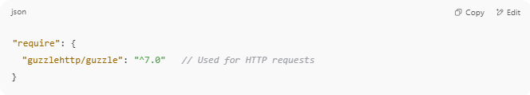
"require": {
"guzzlehttp/guzzle": "^7.0" // Used for HTTP requests
}

➡ Your project needs Guzzle to send HTTP requests. It will crash if Guzzle is missing.

✅ JavaScript (Node.js + npm)
# Source: AI Source: Provided by: [Data Path: Persons Table -> ID Column: 1, Name_En Column: Motasem Essam] -> From: [ChatGPT] on [1/26/2026]
In package.json:
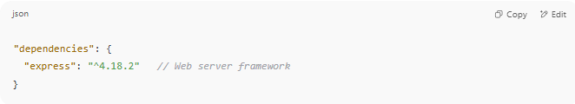
"dependencies": {
"express": "^4.18.2" // Web server framework
}

➡ You need Express to run your server.

🔄 Dependencies vs Dev Dependencies
# Source: AI Source: Provided by: [Data Path: Persons Table -> ID Column: 1, Name_En Column: Motasem Essam] -> From: [ChatGPT] on [1/26/2026]
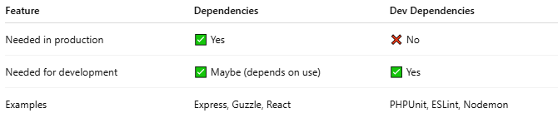

Feature | Dependencies | Dev Dependencies
Needed in production | ✅ Yes | ❌ No
Needed for development | ✅ Maybe (depends on use) | ✅ Yes
Examples | Express, Guzzle, React | PHPUnit, ESLint, Nodemon

📁 When Installed?

Composer:
# Source: AI Source: Provided by: [Data Path: Persons Table -> ID Column: 1, Name_En Column: Motasem Essam] -> From: [ChatGPT] on [1/26/2026]
- composer install → installs both require and require-dev (unless --no-dev is used)

Npm:
# Source: AI Source: Provided by: [Data Path: Persons Table -> ID Column: 1, Name_En Column: Motasem Essam] -> From: [ChatGPT] on [1/26/2026]
- npm install → installs everything
- npm install --production → skips devDependencies

💡 Real-Life Analogy
# Source: AI Source: Provided by: [Data Path: Persons Table -> ID Column: 1, Name_En Column: Motasem Essam] -> From: [ChatGPT] on [1/26/2026]
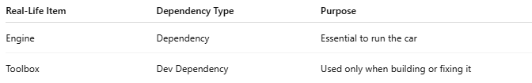

Real-Life Item | Dependency Type | Purpose
Engine | Dependency | Essential to run the car
Toolbox | Dev Dependency | Used only when building or fixing it

Dev Dependencies
# Source: AI Source: Provided by: [Data Path: Persons Table -> ID Column: 1, Name_En Column: Motasem Essam] -> From: [ChatGPT] on [1/26/2026]
Dev Dependencies (short for Development Dependencies) are the packages or libraries that a project needs only during development and testing, not in production.

📦 In PHP (Composer), Node.js (npm), Python (pip), etc.
# Source: AI Source: Provided by: [Data Path: Persons Table -> ID Column: 1, Name_En Column: Motasem Essam] -> From: [ChatGPT] on [1/26/2026]
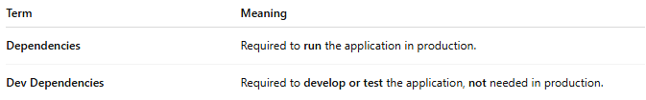
Term | Meaning
Dependencies | Required to run the application in production.
Dev Dependencies | Required to develop or test the application, not needed in production.

✅ Examples of Dev Dependencies

In a PHP project (composer.json)
# Source: AI Source: Provided by: [Data Path: Persons Table -> ID Column: 1, Name_En Column: Motasem Essam] -> From: [ChatGPT] on [1/26/2026]
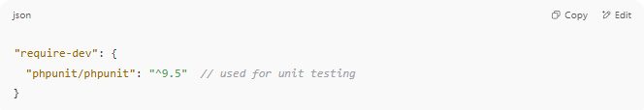
"require-dev": {
"phpunit/phpunit": "^9.5" // used for unit testing
}

In a Node.js project (package.json)
# Source: AI Source: Provided by: [Data Path: Persons Table -> ID Column: 1, Name_En Column: Motasem Essam] -> From: [ChatGPT] on [1/26/2026]
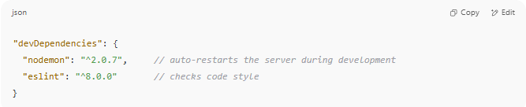
"devDependencies": {
"nodemon": "^2.0.7", // auto-restarts the server during development
"eslint": "^8.0.0" // checks code style
}

⚙️ Use Cases
# Source: AI Source: Provided by: [Data Path: Persons Table -> ID Column: 1, Name_En Column: Motasem Essam] -> From: [ChatGPT] on [1/26/2026]
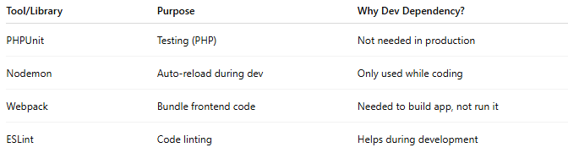

Tool/Library | Purpose | Why Dev Dependency?
PHPUnit | Testing (PHP) | Not needed in production
Nodemon | Auto-reload during dev | Only used while coding
Webpack | Bundle frontend code | Needed to build app, not run it
ESLint | Code linting | Helps during development

📌 Why separate them?
# Source: AI Source: Provided by: [Data Path: Persons Table -> ID Column: 1, Name_En Column: Motasem Essam] -> From: [ChatGPT] on [1/26/2026]
- ✅ Smaller production size
- ✅ Faster deployment
- ✅ Better security (fewer packages = fewer risks)

📦 Package Manager vs Dependency Manager
# Source: AI Source: Provided by: [Data Path: Persons Table -> ID Column: 1, Name_En Column: Motasem Essam] -> From: [ChatGPT] on [1/26/2026]
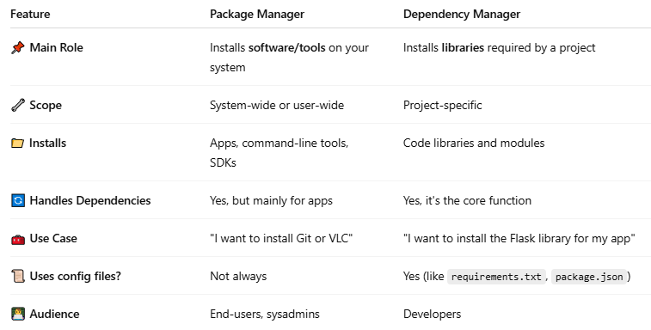

Feature | Package Manager | Dependency Manager
📌 Main Role | Installs software/tools on your system | Installs libraries required by a project
🔧 Scope | System-wide or user-wide | Project-specific
📁 Installs | Apps, command-line tools, SDKs | Code libraries and modules
🔄 Handles Dependencies | Yes, but mainly for apps | Yes, it's the core function
🧰 Use Case | "I want to install Git or VLC" | "I want to install the Flask library for my app"
📜 Uses config files? | Not always | Yes (like requirements.txt, package.json)
👨‍💻 Audience | End-users, sysadmins | Developers

🔧 Examples of Package Managers:
# Source: AI Source: Provided by: [Data Path: Persons Table -> ID Column: 1, Name_En Column: Motasem Essam] -> From: [ChatGPT] on [1/26/2026]
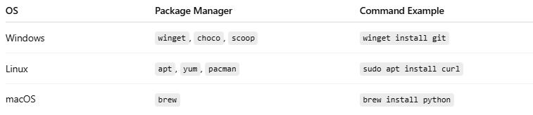

OS | Package Manager | Command Example
Windows | winget, choco, scoop | winget install git
Linux | apt, yum, pacman | sudo apt install curl
macOS | brew | brew install python

🧱 Examples of Dependency Managers:
# Source: AI Source: Provided by: [Data Path: Persons Table -> ID Column: 1, Name_En Column: Motasem Essam] -> From: [ChatGPT] on [1/26/2026]
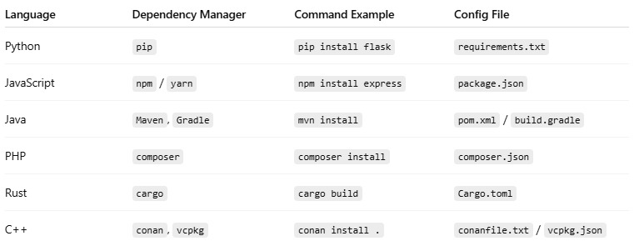

Language | Dependency Manager | Command Example | Config File
Python | pip | pip install flask | requirements.txt
JavaScript | npm / yarn | npm install express | package.json
Java | Maven, Gradle | mvn install | pom.xml / build.gradle
PHP | composer | composer install | composer.json
Rust | cargo | cargo build | Cargo.toml
C++ | conan, vcpkg | conan install . | conanfile.txt / vcpkg.json

🧠 Key Difference:
# Source: AI Source: Provided by: [Data Path: Persons Table -> ID Column: 1, Name_En Column: Motasem Essam] -> From: [ChatGPT] on [1/26/2026]
- Package managers: Focus on software/tools for your system.
- Dependency managers: Focus on libraries/code your project needs to run or compile.

Is every package manager a dependency manager? And is every dependency manager a package manager?
- Not all package managers are dependency managers.
  - Example: apt, yum, Homebrew, Chocolatey install software packages on your system, but they don’t manage project-specific dependencies automatically.
- Not all dependency managers are package managers.
  - Example: Maven, Gradle, yarn,(project mode) manage libraries your project depends on, but they usually don’t install full system software.
- Some tools can act as both (like npm, pip, which can install system-wide packages or project dependencies), but in general:
  - Package manager = installs software packages on a system
  - Dependency manager = manages libraries your project needs

📌 In Summary:
# Source: AI Source: Provided by: [Data Path: Persons Table -> ID Column: 1, Name_En Column: Motasem Essam] -> From: [ChatGPT] on [1/26/2026]
A dependency manager:
- Keeps your project working
- Saves time and errors
- Makes collaboration and deployment easier

